**Project Initialization and Planning Phase**

| Date | 23-09-2024 |
| --- | --- |
| Team ID | LTVIP2024TMID25000 |
| Project Name | SMS Spam Detection - AIML |
| Maximum Marks | 3 Marks |

**Define Problem Statements (Customer Problem Statement Template):**

The increasing amount of SMS spam is a growing concern for users. Spam messages often contain fraudulent schemes, unwanted promotions, or phishing attempts, making it difficult for users to distinguish between legitimate and spam messages. This project aims to provide an efficient solution to automatically detect and classify SMS messages as either **Spam** or **Not Spam**, enhancing users' trust and experience.

By creating a tool to automatically detect SMS spam, we aim to alleviate the frustration of manually filtering unwanted messages. The solution will contribute to a cleaner inbox and a safer user experience.

**Example:**

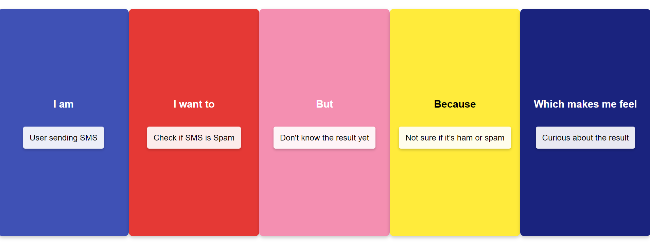

|  |  |  |  |  |  |
| --- | --- | --- | --- | --- | --- |
| **Problem**  **Statement (PS)** | **I am**  **(Customer)** | **I’m trying to** | **But** | **Because** | **Which makes me feel** |
| PS-1 | A user regularly receiving SMS messages, both legitimate and spam. | Identify whether an SMS message is legitimate or spam without having to manually filter through my inbox. | Spam messages often look like legitimate messages, and filtering through them manually is time-consuming and frustrating. | Some spam messages contain fraudulent information or unwanted promotions, potentially leading to scams or security breaches. | Worried about security, and annoyed by the constant influx of spam messages. |